Client output

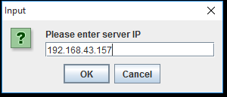

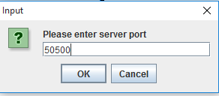

Then client is connected to server

You can view client desktop in server and control it using mouse and keyboard